Assignment 1: Getting Started

In this assignment, you will set up a Python environment and configure Visual Studio Code (VS Code) as your Integrated Development Environment (IDE). Although you are welcome to use any IDE you choose, we will be using VS Code in examples. You are also required to create a GitHub account if you do not already have one. Finally, you will tackle programming your first sorting algorithm.

Step 1: Install Python
If you do not already have Python installed, you can download it from the official website: https://www.python.org/downloads. You must use version 3.8 or higher. When you run the installer, be sure to check the option ‘Add Python to PATH’.

To check the installation, use python --version on the terminal or command prompt on your system.
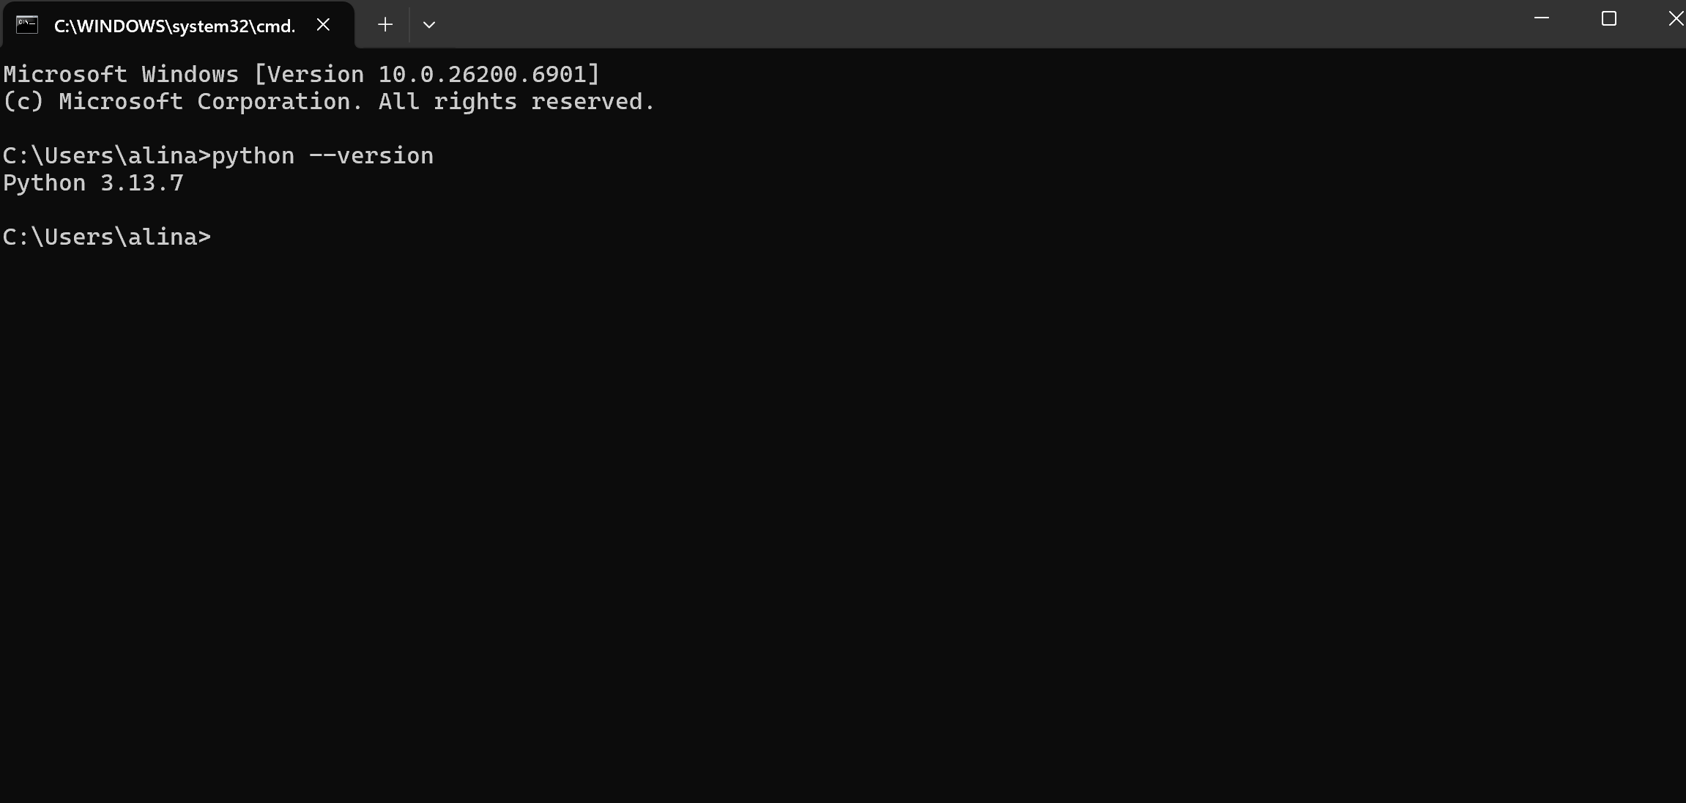

Step 2: Install Visual Studio Code (VS Code) or an IDE of choice
You can download VS Code for Windows, MacOS, or Linux from their website: https://code.visualstudio.com/. If you have used VS Code before, you want to make sure you have the latest version. Run the installer and follow the instructions to install it on your machine. Once the installation is complete, you will need to install the Python Extension for VS Code.

- Open Visual Studio Code
- Go to the Extensions view by clicking the Extension icon in the Activity Bar.
- Search for ‘Python’ and select the official Python extension by Microsoft.
- 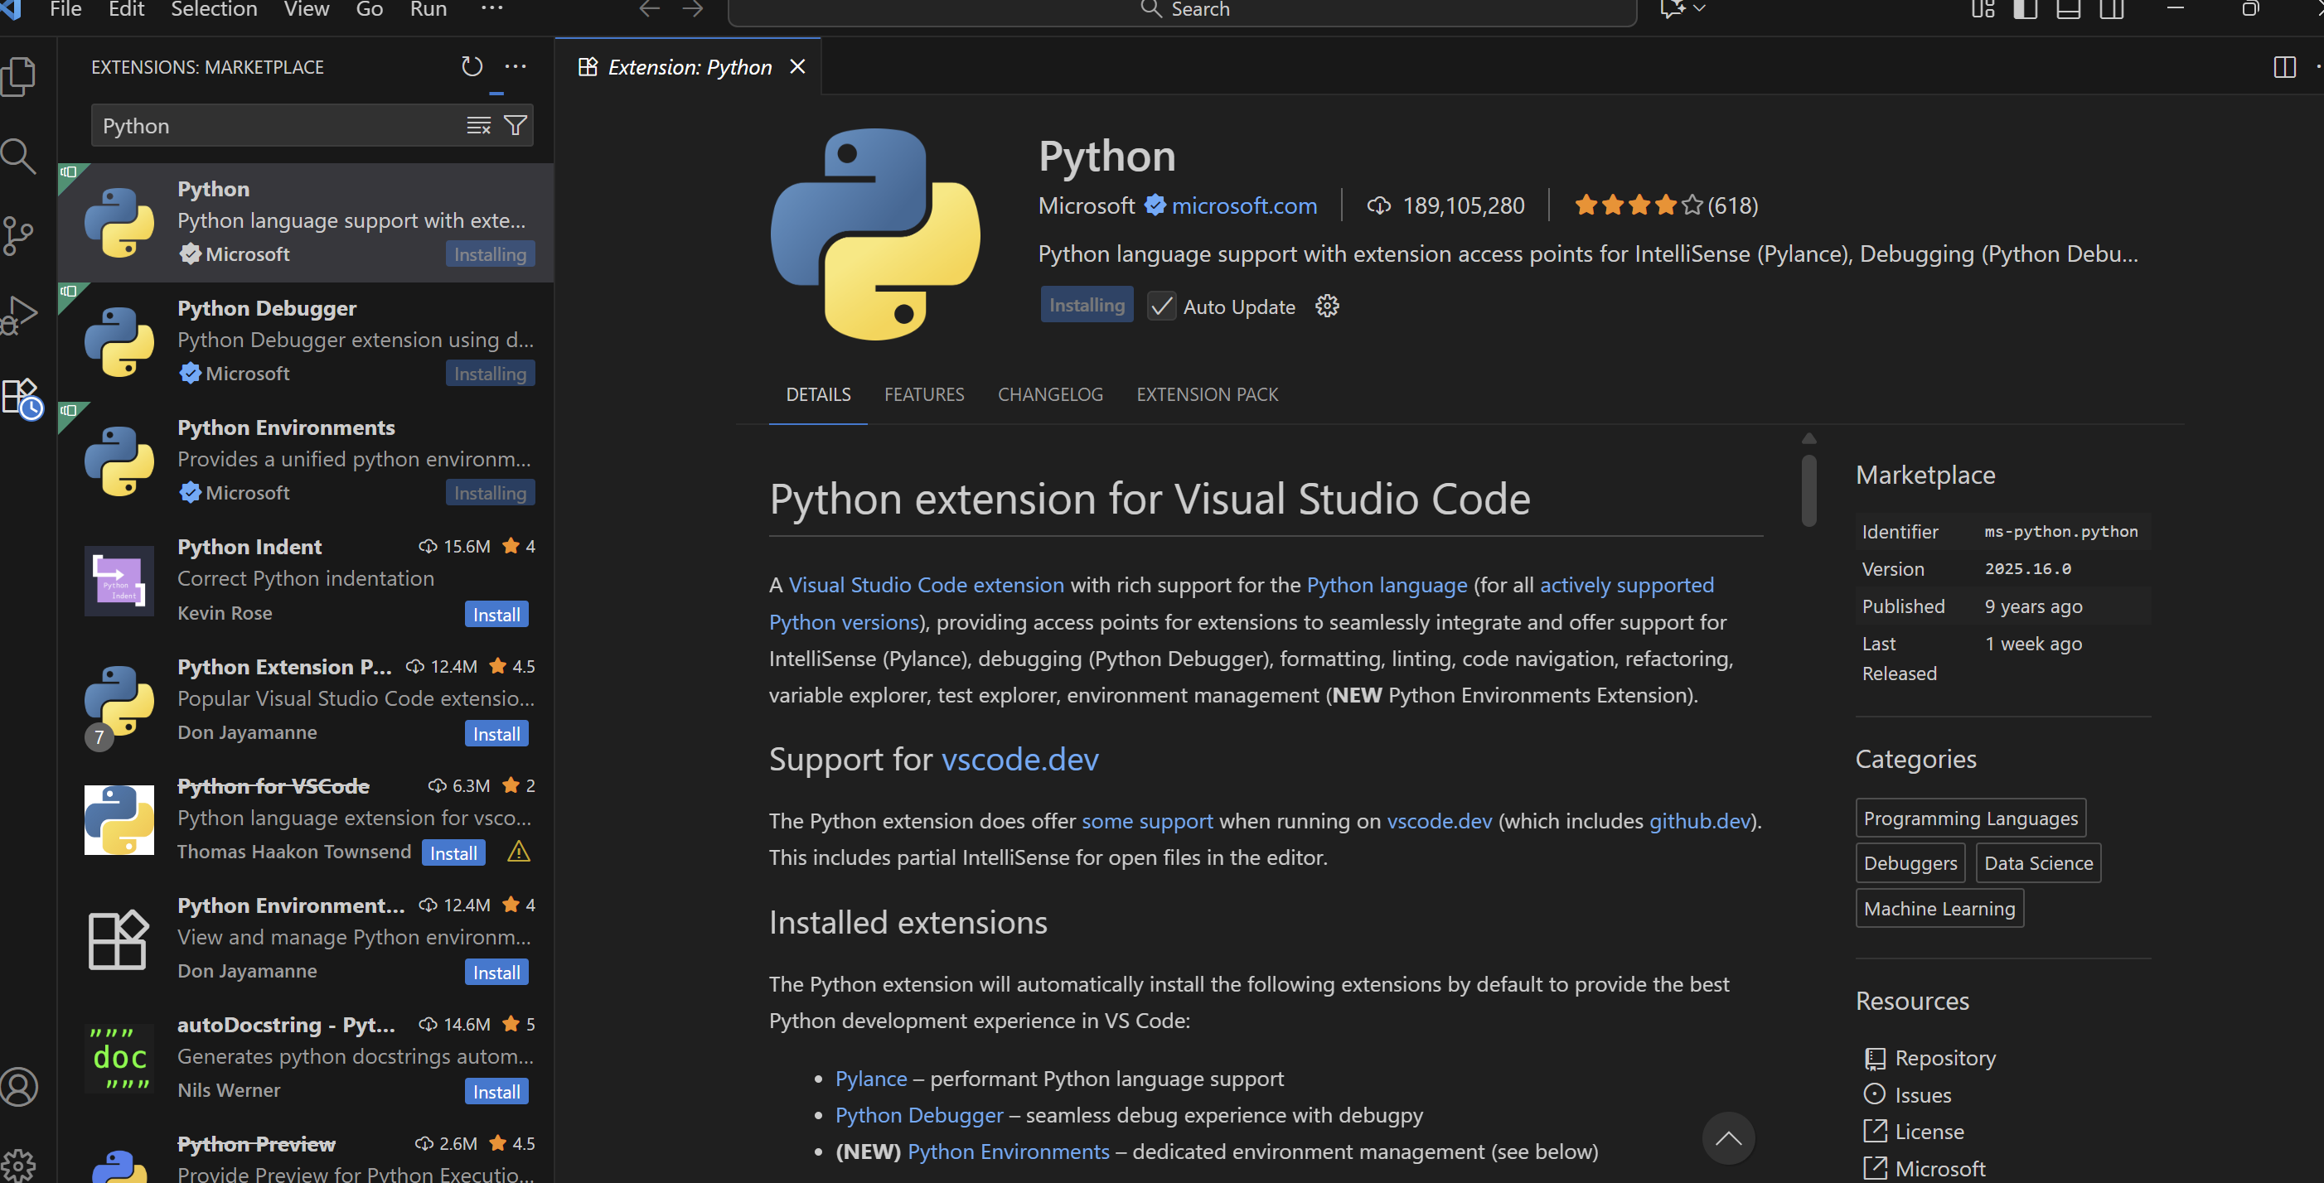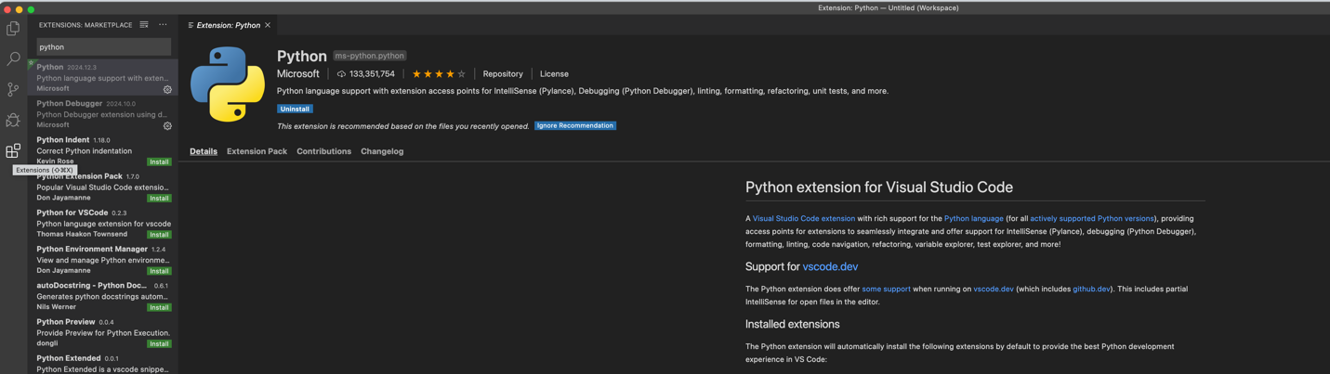
- Click Install to add the Python extension to VS Code.
- I also recommend installing the Code Runner extension. Here’s a video that shows the installation steps covered so far including Code Runner : https://www.youtube.com/watch?v=9o4gDQvVkLU

Step 3: GitHub Account Creation
GitHub is a cornerstone of modern software development that facilitates collaboration, version control, and project management. Go to https://github.com/ to create an account using your UCumberlands email address. Setting up GitHub to work with VS Code can be a little confusing. Watch this video to help you get it set up: https://youtu.be/z5jZ9lrSpqk?si=olDHgwvpsNbtiwAB

https://github.com/ksyed5837
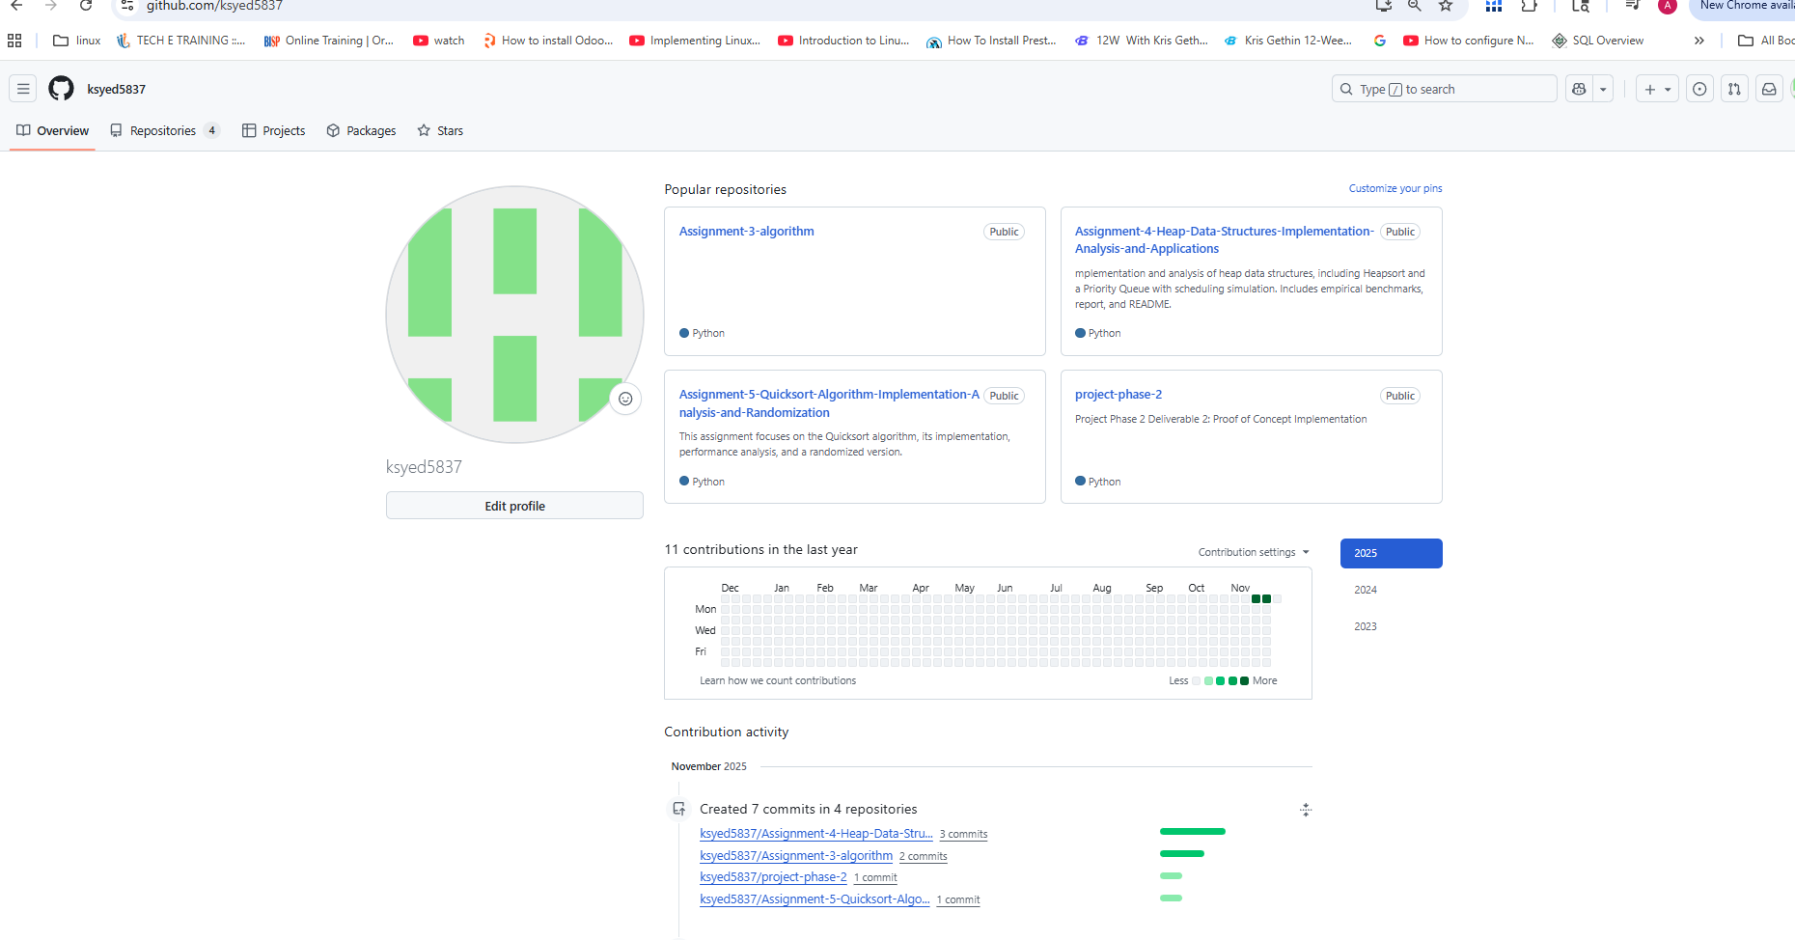

Step 4: Assignment
Now that you are all set up, it is time to do a little programming. In Chapter 2 of Introduction to Algorithms, the Insertion Sort is introduced. Using what you learned from the algorithm presented, code the Insertion Sort algorithm; however, you will sort your array into monotonically decreasing order instead of increasing. To practice using version control, you should have at least 3 commits to your GitHub repository. Name your repo MSCS532_Assignment1 and make the repo public. Here’s a summary:
- Write a Python program for the Insertion Sort Algorithm that sorts in monotonically decreasing order.
- Have at least 3 commits to your public MSCS532_Assignment1 repo to show your development process.
- Submit the link to your public MSCS532_Assignment1 repository.

https://github.com/ksyed5837/MSCS532_Assignment1

Cormen, T. H., Leiserson, C. E., Rivest, R. L., & Stein, C. (2022). Introduction to Algorithms (4th ed.). Random House Publishing Services. https://reader2.yuzu.com/books/9780262367509

